CHAPTER 7 - THE ASSEMBLY LANGUAGE LEVEL

Assembly Language is the alphanumeric correspondence of the hex ISA level.

(During execution, three levels are in evidence: operating system level, ISA level and microarchitecture level.
Consequently, three programs can be found in computer's memory: the user's object program, the operating system and the microprogram.)

INTRODUCTION TO ASSEMBLY LANGUAGE

Translators are divided into two groups: compilers and assemblers

What is an Assembly Language?

A pure assembly language is a language in which each statement produces exactly one macjhine instruction.
- An n-line assembly program will produce an n-word machine language program.
- Machine language is in hexadecimal, assembly language is more understandable
- The assembly programmer has access to all the features and instructions available on the target machine. High level languages don't have this feature.
- An assembly language program can run on a family of machines, whereas a high level program can run on many machines.

Why Use Assembly Language?

1.Writing an assembly program is difficult. It takes longer to debug and harder to maintain. There are 2 reasons to use assembly language: performance and access to the machine.

2.Assembly code is sometimes the only alternative due to lack of memory.
3. Understanding assembly language is essential to understanding how compilers work.

4.Studying assembly language exposes the real machine to view.

Format of an Assembly Language Statement

Label Opcode Operands Comments

Pseudoinstructions : commands to the assembler

SEGMENT, EQU, DB, DW...

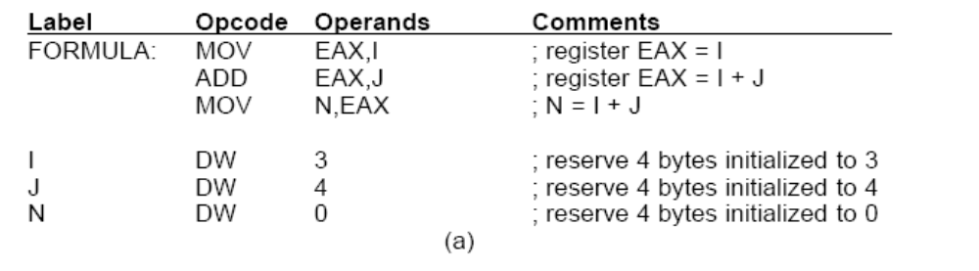
THE ASSEMBLY PROCESS

Two Pass Assemblers

Pass one:
Forward references are handled and an intermediate form is obtained.
- The definitions of symbols, labels are collected and stored in a table.
- Assembly program is read once, converted to an intermediate form in a table in memory using the table mentioned in step 1. Then a second pass is made over the table instead of the source program.
Another task of pass one is to save all macro definitions and expand the calls as they are encountered. Thus, defining the symbols and expanding the macros are generally combined into one pass.

Pass two: The function of pass two is to generate the object program and possibly print the assembly listing. In addition, pass two must output certain information needed by the linker for linking up procedures assembled at different times into a single executable file.

The operation of pass two: It reads the lines one at a time and processes them one at a time.

Another task of Pass two is to detect errors. Some of the common errors are:

- A symbol has been used, but not defined.
- A symbol has been defined more than once.
- The name in the opcode field is not a legal one.
- An opcode is not supplied with enough operands.
- An opcode is supplied with too many operands.
- An octal number contains an 8 or 9.
- Illegal register use (branch to a register).
- The END statement is mssing.

The best thing for the assembler to do with an errant statement is to print an error message and try to continue assembly.

LINKING AND LOADING

Linking: obtaining one .exe file from separately compiled object modules.

Loading: Loading one .exe file to the memory for execution.

Compilers and assemblers generally translate one module at a time and put the translated output on a disk. Before the program can be run, all the translated procedures must be found and linked together properly. The complete translation of a source program requires two steps:

- Compilation or assembly of the source procedures.
- Linking of the object modules.

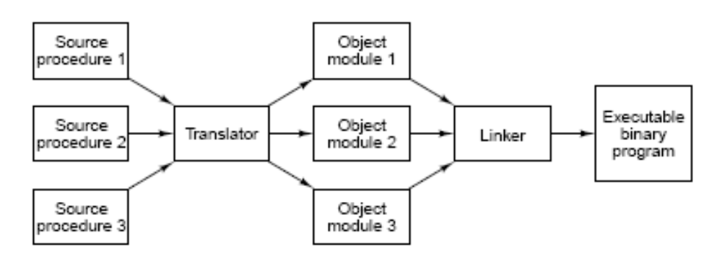

The translation of a source procedure to object module represents a change in level because the source language and target language have different instructions and notation. The linking process does not represent a change in level, since both the linker's input and the linker's output are programs for the same virtual machine. The linker's function is to collect procedures translated separately and link them together to be run as a unit called executable binary program.

Why do compilers and assemblers translate each source module as a separate entity? If a compiler or assembler were to read a series of source modules and directly produce a ready-to-run machine language program, changing one statement in one source module would require that all the source modules be translated. In separate-object-module technique, it is only necessary to retranslate the modified procedure and not the unchanged ones, although it is necessary to relink all the object modules again.

Tasks Performed by the Linker:

- relocation
- resolving external references

The linker merges the separate address spaces of the object modules into a single linear address space in the following steps:

- It constructs a table of all the object modules and their lengths.
- Based on this table, it assigns a starting address to each object module.
- It finds all the instructions that reference memory adds to each a relocation constant equal to the address of its module.
- It finds all the instructions that reference other procedures and inserts the address of these procedures in place.

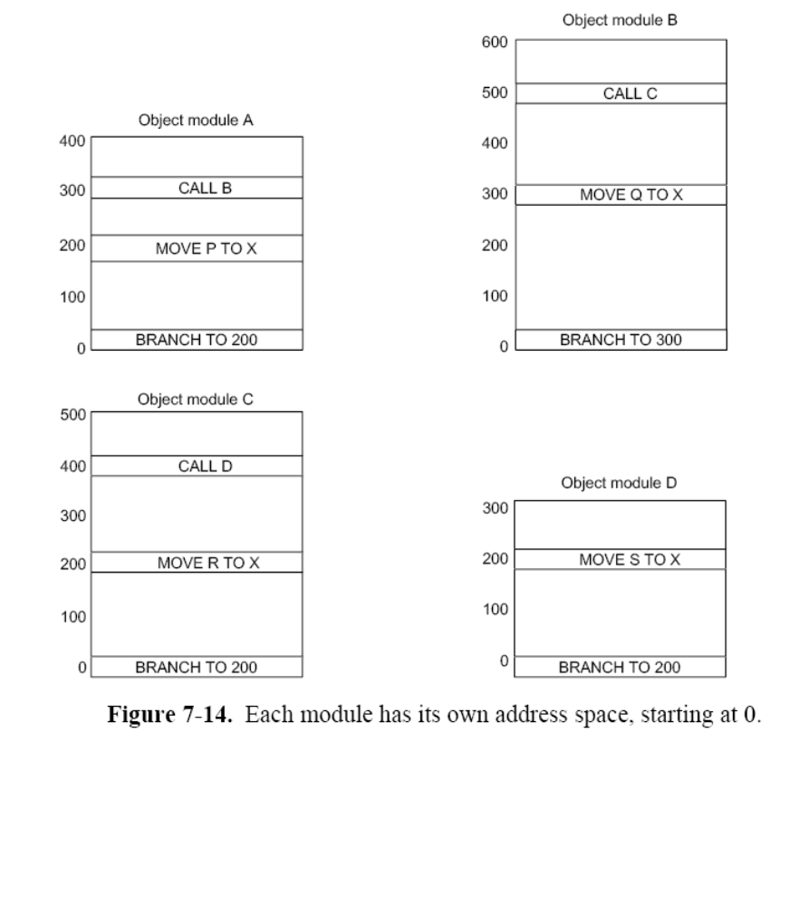

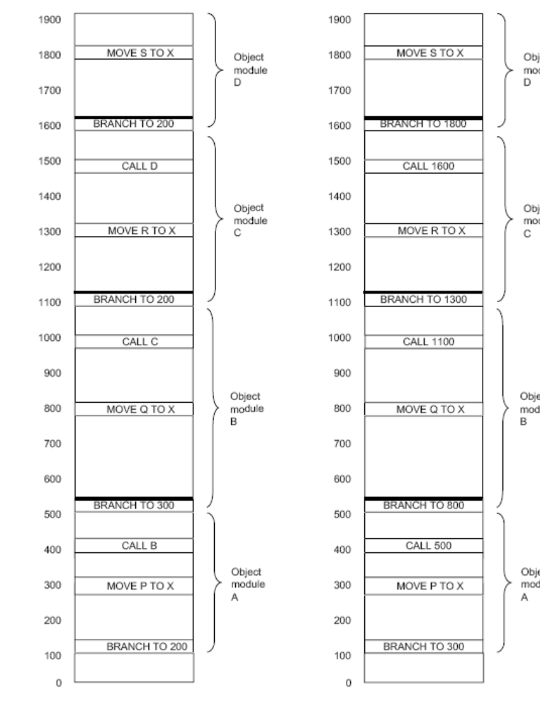

Binding Time and Dynamic Relocation

During loading, logical addresses in the .exe file are converted to physical memory addresses.

Binding to physical addresses: paging

